| Please choose a lesson, or type 0 to return to course menu.

1: Principles of Analytic Graphs 2: Exploratory Graphs 3: Graphics Devices in R

4: Plotting Systems 5: Base Plotting System 6: Lattice Plotting System

7: Working with Colors 8: GGPlot2 Part1 9: GGPlot2 Part2

10: GGPlot2 Extras 11: Hierarchical Clustering 12: K Means Clustering

13: Dimension Reduction 14: Clustering Example 15: CaseStudy

Selection: 8

| Attemping to load lesson dependencies...

| Package ‘ggplot2’ loaded correctly!

| | 0%

| GGPlot2_Part1. (Slides for this and other Data Science courses may be found at github

| https://github.com/DataScienceSpecialization/courses/. If you care to use them, they must be downloaded as a

| zip file and viewed locally. This lesson corresponds to 04_ExploratoryAnalysis/ggplot2.)

...

|== | 2%

| In another lesson, we gave you an overview of the three plotting systems in R. In this lesson we'll focus on

| the third and newest plotting system in R, ggplot2. As we did with the other two systems, we'll focus on

| creating graphics on the screen device rather than another graphics device.

...

|===== | 5%

| The ggplot2 package is an add-on package available from CRAN via install.packages(). (Don't worry, we've

| installed it for you already.) It is an implementation of The Grammar of Graphics, an abstract concept (as

| well as book) authored and invented by Leland Wilkinson and implemented by Hadley Wickham while he was a

| graduate student at Iowa State. The web site http://ggplot2.org provides complete documentation.

...

|======= | 7%

| A grammar of graphics represents an abstraction of graphics, that is, a theory of graphics which

| conceptualizes basic pieces from which you can build new graphics and graphical objects. The goal of the

| grammar is to â€œShorten the distance from mind to pageâ€. From Hadley Wickham's book we learn that

...

|========== | 10%

| The ggplot2 package "is composed of a set of independent components that can be composed in many different

| ways. ... you can create new graphics that are precisely tailored for your problem." These components

| include aesthetics which are attributes such as colour, shape, and size, and geometric objects or geoms such

| as points, lines, and bars.

...

|============ | 12%

| Before we delve into details, let's review the other 2 plotting systems.

...

|=============== | 15%

| Recall what you know about R's base plotting system. Which of the following does NOT apply to it?

1: Use annotation functions to add/modify (text, lines, points, axis)

2: It is convenient and mirrors how we think of building plots and analyzing data

3: Start with plot (or similar) function

4: Can easily go back once the plot has started (e.g., to adjust margins or correct a typo)

Selection: 4

| You are amazing!

|================= | 17%

| Recall what you know about R's lattice plotting system. Which of the following does NOT apply to it?

1: Margins and spacing are set automatically because entire plot is specified at once

2: Can always add to the plot once it is created

3: Plots are created with a single function call (xyplot, bwplot, etc.)

4: Most useful for conditioning types of plots and putting many panels on one plot

Selection: 2

| You got it right!

|==================== | 20%

| If we told you that ggplot2 combines the best of base and lattice, that would mean it ...?

1: Like lattice it allows for multipanels but more easily and intuitively

2: All of the others

3: Its default mode makes many choices for you (but you can customize!)

4: Automatically deals with spacings, text, titles but also allows you to annotate

Selection: 2

| You got it!

|====================== | 22%

| Yes, ggplot2 combines the best of base and lattice. It allows for multipanel (conditioning) plots (as

| lattice does) but also post facto annotation (as base does), so you can add titles and labels. It uses the

| low-level grid package (which comes with R) to draw the graphics. As part of its grammar philosophy, ggplot2

| plots are composed of aesthetics (attributes such as size, shape, color) and geoms (points, lines, and

| bars), the geometric objects you see on the plot.

...

|========================= | 24%

| The ggplot2 package has 2 workhorse functions. The more basic workhorse function is qplot, (think quick

| plot), which works like the plot function in the base graphics system. It can produce many types of plots

| (scatter, histograms, box and whisker) while hiding tedious details from the user. Similar to lattice

| functions, it looks for data in a data frame or parent environment.

...

|=========================== | 27%

| The more advanced workhorse function in the package is ggplot, which is more flexible and can be customized

| for doing things qplot cannot do. In this lesson we'll focus on qplot.

...

|============================== | 29%

| We'll start by showing how easy and versatile qplot is. First, let's look at some data which comes with the

| ggplot2 package. The mpg data frame contains fuel economy data for 38 models of cars manufactured in 1999

| and 2008. Run the R command str with the argument mpg. This will give you an idea of what mpg contains.

> str(mpg)

Classes ‘tbl_df’, ‘tbl’ and 'data.frame': 234 obs. of 11 variables:

$ manufacturer: chr "audi" "audi" "audi" "audi" ...

$ model : chr "a4" "a4" "a4" "a4" ...

$ displ : num 1.8 1.8 2 2 2.8 2.8 3.1 1.8 1.8 2 ...

$ year : int 1999 1999 2008 2008 1999 1999 2008 1999 1999 2008 ...

$ cyl : int 4 4 4 4 6 6 6 4 4 4 ...

$ trans : chr "auto(l5)" "manual(m5)" "manual(m6)" "auto(av)" ...

$ drv : chr "f" "f" "f" "f" ...

$ cty : int 18 21 20 21 16 18 18 18 16 20 ...

$ hwy : int 29 29 31 30 26 26 27 26 25 28 ...

$ fl : chr "p" "p" "p" "p" ...

$ class : chr "compact" "compact" "compact" "compact" ...

| Keep working like that and you'll get there!

|================================ | 32%

| We see that there are 234 points in the dataset concerning 11 different characteristics of the cars. Suppose

| we want to see if there's a correlation between engine displacement (displ) and highway miles per gallon

| (hwy). As we did with the plot function of the base system we could simply call qplot with 3 arguments, the

| first two are the variables we want to examine and the third argument data is set equal to the name of the

| dataset which contains them (in this case, mpg). Try this now.

> qplot(displ, hwy, data = mpg)

| You got it!

|================================== | 34%

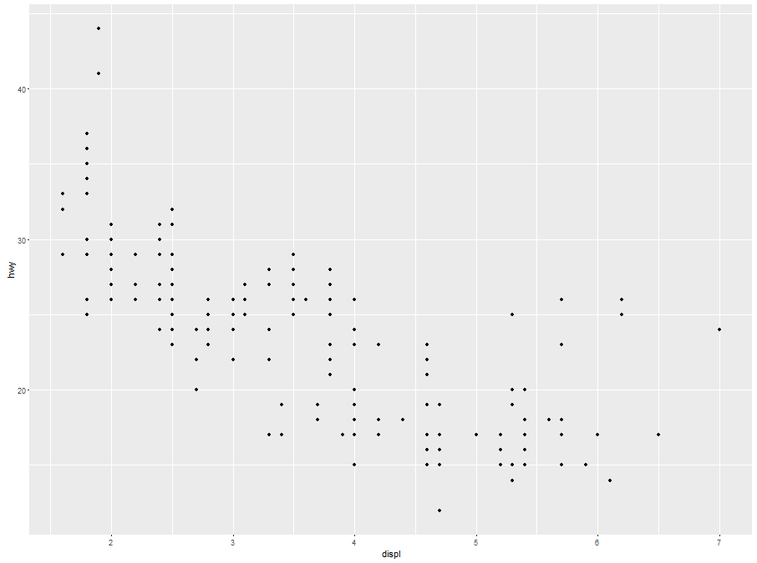

| A nice scatterplot done simply, right? All the labels are provided. The first argument is shown along the

| x-axis and the second along the y-axis. The negative trend (increasing displacement and lower gas mileage)

| is pretty clear. Now suppose we want to do the same plot but this time use different colors to distinguish

| between the 3 factors (subsets) of different types of drive (drv) in the data (front-wheel, rear-wheel, and

| 4-wheel). Again, qplot makes this very easy. We'll just add what ggplot2 calls an aesthetic, a fourth

| argument, color, and set it equal to drv. Try this now. (Use the up arrow key to save some typing.)

> qplot(displ, hwy, data = mpg, color = drv)

| That's the answer I was looking for.

|===================================== | 37%

| Pretty cool, right? See the legend to the right which qplot helpfully supplied? The colors were

| automatically assigned by qplot so the legend decodes the colors for you. Notice that qplot automatically

| used dots or points to indicate the data. These points are geoms (geometric objects). We could have used a

| different aesthetic, for instance shape instead of color, to distinguish between the drive types.

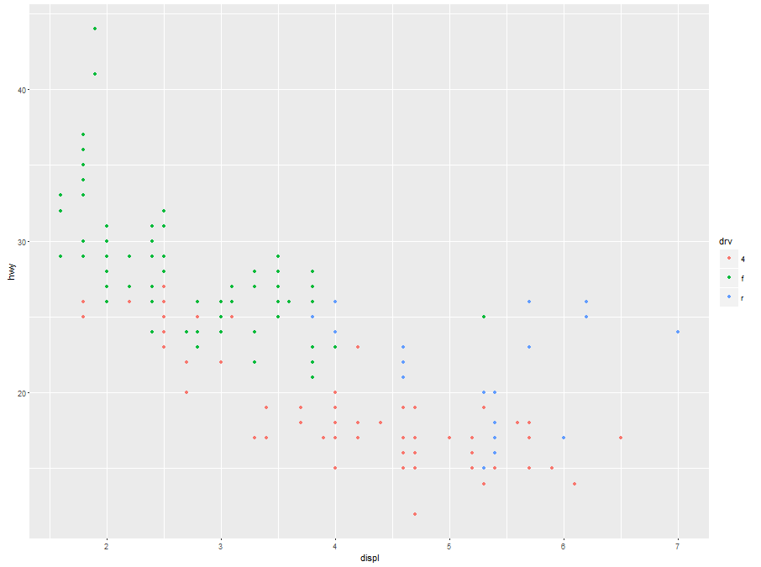

...

|======================================= | 39%

| Now let's add a second geom to the default points. How about some smoothing function to produce trend lines,

| one for each color? Just add a fifth argument, geom, and using the R function c(), set it equal to the

| concatenation of the two strings "point" and "smooth". The first refers to the data points and second to the

| trend lines we want plotted. Try this now.

> qplot(displ, hwy, data = mpg, color = drv, geom = c("point", "smooth"))

| Keep working like that and you'll get there!

|========================================== | 41%

| Note the helpful message R returns in red telling you what function (loess) it used to create the trend

| lines. No need to worry - we'll see another example of method in another (Extras) lesson. Notice the gray

| areas surrounding each trend lines. These indicate the 95% confidence intervals for the lines.

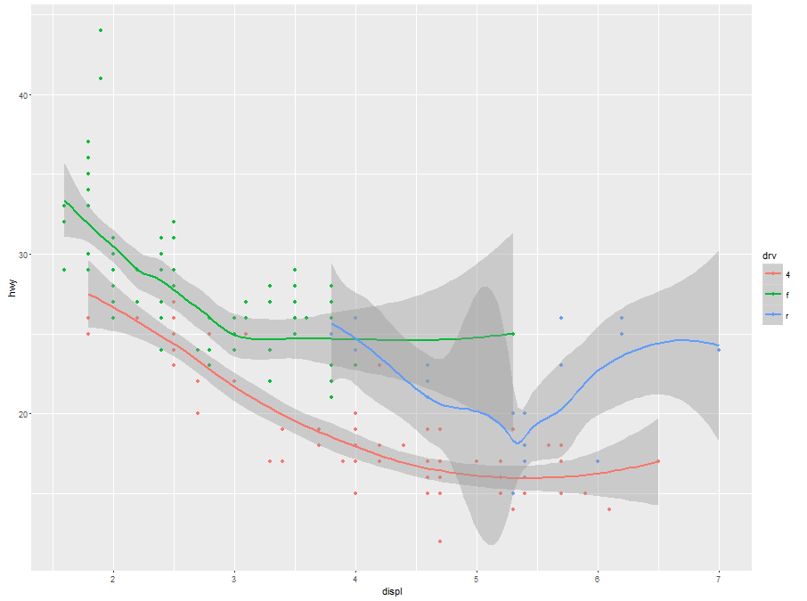

...

|============================================ | 44%

| Before we leave qplot's scatterplotting ability, call qplot again, this time with 3 arguments. The first is

| y set equal to hwy, the second is data set equal to mpg, and the third is color set equal to drv. Try this

| now.

> qplot(y = hwy, data = mpg, color = drv)

| Perseverance, that's the answer.

|=============================================== | 46%

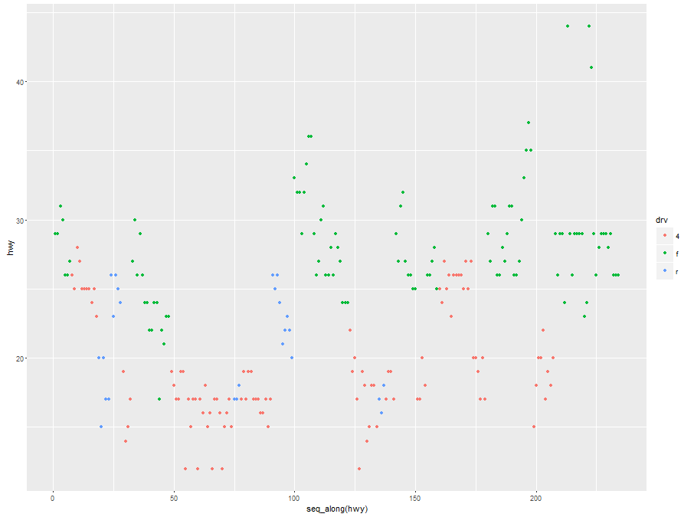

| What's this plot showing? We see the x-axis ranges from 0 to 250 and we remember that we had 234 data points

| in our set, so we can infer that each point in the plot represents one of the hwy values (indicated by the

| y-axis). We've created the vector myhigh for you which contains the hwy data from the mpg dataset. Look at

| myhigh now.

> myhigh

[1] 29 29 31 30 26 26 27 26 25 28 27 25 25 25 25 24 25 23 20 15 20 17 17 26 23 26 25 24 19 14 15 17 27 30 26

[36] 29 26 24 24 22 22 24 24 17 22 21 23 23 19 18 17 17 19 19 12 17 15 17 17 12 17 16 18 15 16 12 17 17 16 12

[71] 15 16 17 15 17 17 18 17 19 17 19 19 17 17 17 16 16 17 15 17 26 25 26 24 21 22 23 22 20 33 32 32 29 32 34

[106] 36 36 29 26 27 30 31 26 26 28 26 29 28 27 24 24 24 22 19 20 17 12 19 18 14 15 18 18 15 17 16 18 17 19 19

[141] 17 29 27 31 32 27 26 26 25 25 17 17 20 18 26 26 27 28 25 25 24 27 25 26 23 26 26 26 26 25 27 25 27 20 20

[176] 19 17 20 17 29 27 31 31 26 26 28 27 29 31 31 26 26 27 30 33 35 37 35 15 18 20 20 22 17 19 18 20 29 26 29

[211] 29 24 44 29 26 29 29 29 29 23 24 44 41 29 26 28 29 29 29 28 29 26 26 26

| Perseverance, that's the answer.

|================================================= | 49%

| Comparing the values of myhigh with the plot, we see the first entries in the vector (29, 29, 31, 30,...)

| correspond to the leftmost points in the the plot (in order), and the last entries in myhigh (28, 29, 26,

| 26, 26) correspond to the rightmost plotted points. So, specifying the y parameter only, without an x

| argument, plots the values of the y argument in the order in which they occur in the data.

...

|==================================================== | 51%

| The all-purpose qplot can also create box and whisker plots. Call qplot now with 4 arguments. First specify

| the variable by which you'll split the data, in this case drv, then specify the variable which you want to

| examine, in this case hwy. The third argument is data (set equal to mpg), and the fourth, the geom, set

| equal to the string "boxplot"

> qplot(drv, hwy, data = mpg, geom = "boxplot")

| You got it!

|====================================================== | 54%

| We see 3 boxes, one for each drive. Now to impress you, call qplot with 5 arguments. The first 4 are just as

| you used previously, (drv, hwy, data set equal to mpg, and geom set equal to the string "boxplot"). Now add

| a fifth argument, color, equal to manufacturer.

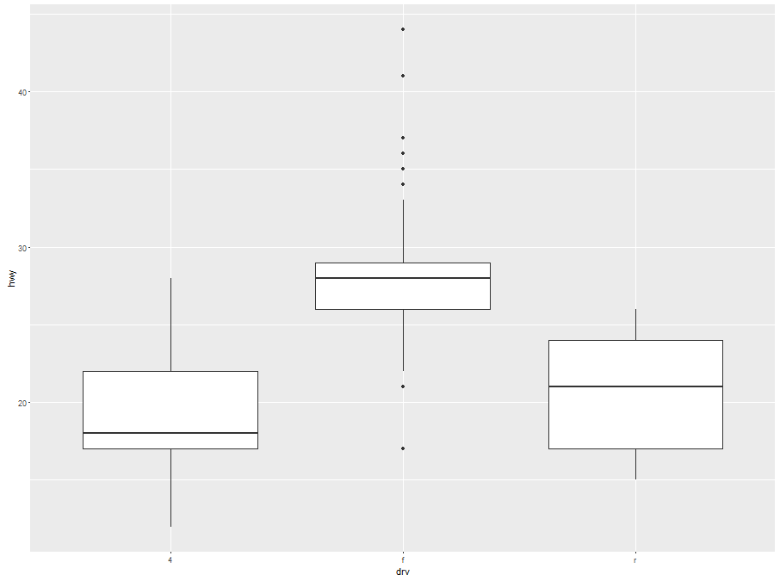

> qplot(drv, hwy, data = mpg, geom = "boxplot", color = manufacturer)

| You got it!

|========================================================= | 56%

| It's a little squished but we just wanted to illustrate qplot's capabilities. Notice that there are still 3

| regions of the plot (determined by the factor drv). Each is subdivided into several boxes depicting

| different manufacturers.

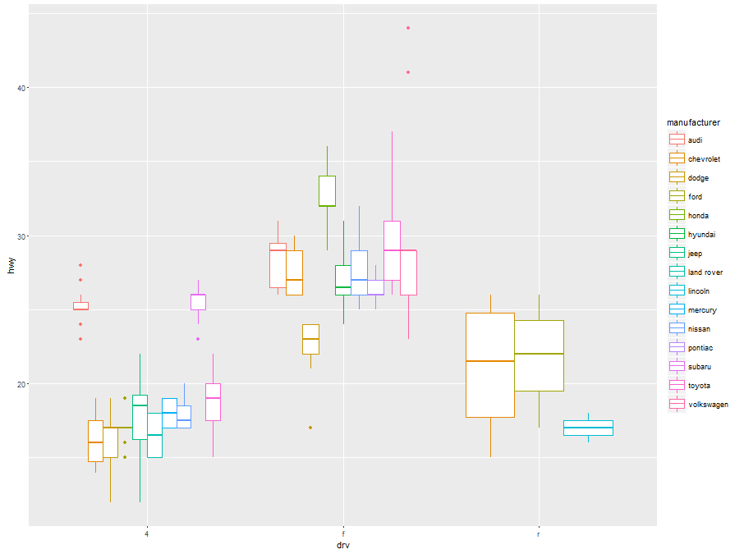

...

|=========================================================== | 59%

| Now, on to histograms. These display frequency counts for a single variable. Let's start with an easy one.

| Call qplot with 3 arguments. First specify the variable for which you want the frequency count, in this case

| hwy, then specify the data (set equal to mpg), and finally, the aesthetic, fill, set equal to drv. Instead

| of a plain old histogram, this will again use colors to distinguish the 3 different drive factors.

> qplot(hwy, data = mpg, fill = drv)

`stat_bin()` using `bins = 30`. Pick better value with `binwidth`.

| You are doing so well!

|============================================================== | 61%

| See how qplot consistently uses the colors. Red (if 4-wheel drv is in the bin) is at the bottom of the bin,

| then green on top of it (if present), followed by blue (rear wheel drv). The color lets us see right away

| that 4-wheel drive vehicles in this dataset don't have gas mileages exceeding 30 miles per gallon.

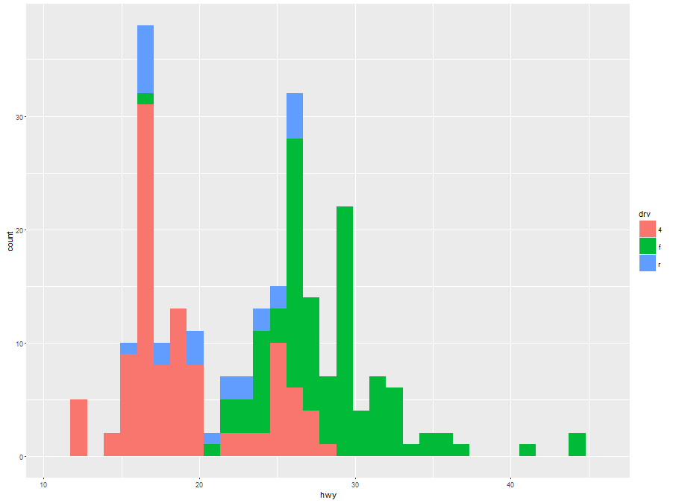

...

|================================================================ | 63%

| It's cool that qplot can do this so easily, but some people may find this multi-color histogram hard to

| interpret. Instead of using colors to distinguish between the drive factors let's use facets or panels.

| (That's what lattice called them.) This just means we'll split the data into 3 subsets (according to drive)

| and make 3 smaller individual plots of each subset in one plot (and with one call to qplot).

...

|=================================================================== | 66%

| Remember that with base plot we had to do each subplot individually. The lattice system made plotting

| conditioning plots easier. Let's see how easy it is with qplot.

...

|===================================================================== | 68%

| We'll do two plots, a scatterplot and then a histogram, each with 3 facets. For the scatterplot, call qplot

| with 4 arguments. The first two are displ and hwy and the third is the argument data set equal to mpg. The

| fourth is the argument facets which will be set equal to the expression . ~ drv which is ggplot2's shorthand

| for number of rows (to the left of the ~) and number of columns (to the right of the ~). Here the .

| indicates a single row and drv implies 3, since there are 3 distinct drive factors. Try this now.

> qplot(displ, hwy, data = mpg, facets = . ~ drv)

| You are amazing!

|======================================================================= | 71%

| The result is a 1 by 3 array of plots. Note how each is labeled at the top with the factor label (4,f, or

| r). This shows us more detailed information than the histogram. We see the relationship between displacement

| and highway mileage for each of the 3 drive factors.

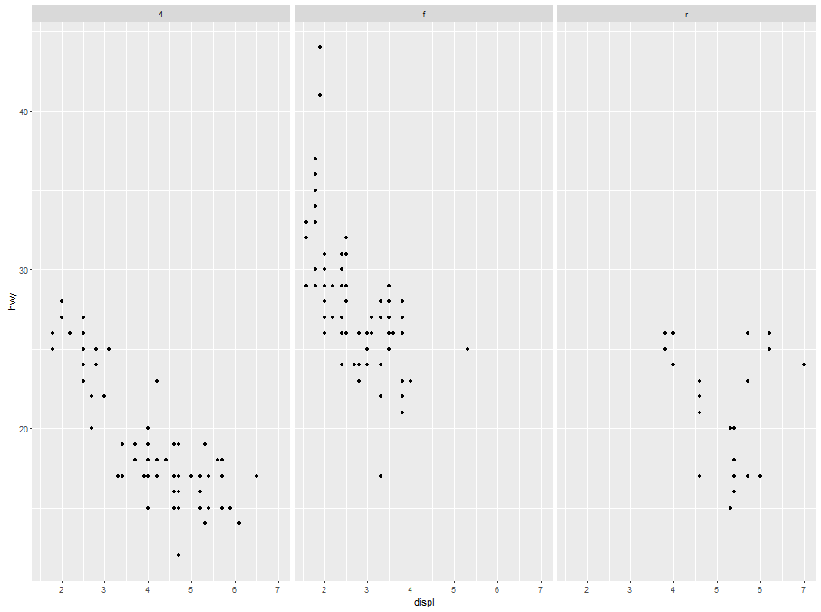

|========================================================================== | 73%

| Now we'll do a histogram, again calling qplot with 4 arguments. This time, since we need only one variable

| for a histogram, the first is hwy and the second is the argument data set equal to mpg. The third is the

| argument facets which we'll set equal to the expression drv ~ . . This will give us a different arrangement

| of the facets. The fourth argument is binwidth. Set this equal to 2. Try this now.

> qplot(hwy, data = mpg, facets = drv ~ ., binwidth = 2)

| Excellent job!

|============================================================================ | 76%

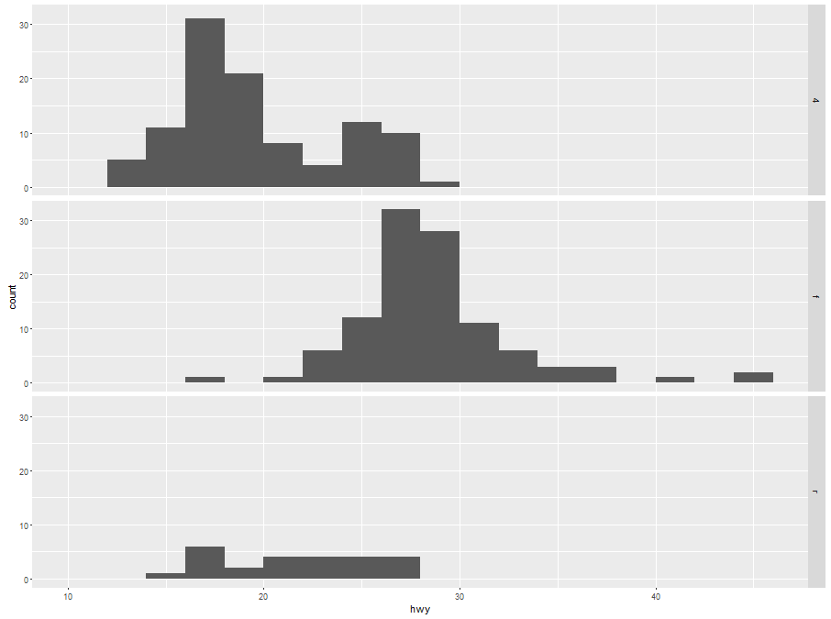

| The facets argument, drv ~ ., resulted in what arrangement of facets?

1: huh?

2: 1 by 3

3: 3 by 1

4: 2 by 2

Selection: 3

| You got it right!

|=============================================================================== | 78%

| Pretty good, right? Not too difficult either. Let's review what we learned!

...

|================================================================================= | 80%

| Which of the following is a basic workhorse function of ggplot2?

1: scatterplot

2: xyplot

3: gplot

4: qplot

5: hist

Selection: 4

| Great job!

|==================================================================================== | 83%

| Which types of plot does qplot plot?

1: histograms

2: box and whisker plots

3: all of the others

4: scatterplots

Selection: 3

| That's the answer I was looking for.

|====================================================================================== | 85%

| What does the gg in ggplot2 stand for?

1: good grief

2: goto graphics

3: good graphics

4: grammar of graphics

Selection: 4

| Perseverance, that's the answer.

|========================================================================================= | 88%

| True or False? The geom argument takes a string for a value.

1: False

2: True

Selection: 2

| You're the best!

|=========================================================================================== | 90%

| True or False? The data argument takes a string for a value.

1: False

2: True

Selection: 1

| That's correct!

|============================================================================================== | 93%

| True or False? The binwidth argument takes a string for a value.

1: True

2: False

Selection: 2

| Keep working like that and you'll get there!

|================================================================================================ | 95%

| True or False? The user must specify x- and y-axis labels when using qplot.

1: True

2: False

Selection: 2

| You are really on a roll!

|=================================================================================================== | 98%

| Congrats! You've finished plot 1 of ggplot2. In the next lesson the plot thickens.

...

|=====================================================================================================| 100%